**Part 1:**

**Part2:**

For devises / routers / servers

1111 1111.1111 1111.1111 1111.0000 0000 (255.255.255.0)

1111 1111.1111 1111.1111 1111.1110 0000 (255.255.255.224) (0.0.0.31)

For Routers

1111 1111.1111 1111.1111 1111.0000 0000 (255.255.255.0)

1111 1111.11111 1111.1111 1111.1111 1100 (255.255.255.252) (0.0.0.3)

172.16.16.0/24

2^x = 5 -----> 3 for future

x = 8

24 + 3 = 27

The new Ip address 172.16.16.0/27

block size 2^5 = 32

= 30 available hosts

255.255.255.0

255.255.255.252/30

Block size 2^2 = 4

4-2 = 2 subnet masks available

5 networks for now

172.16.16.0

172.16.16.32

172.16.16.64

172.16.16.96

172.16.16.128

3 networks for future

172.16.16.160

172.16.16.192

172.16.16.224

|  |  |  |  |  |  |
| --- | --- | --- | --- | --- | --- |
| Network Ip | First Valid IP - Last Valid IP | Broadcast | Subnet | Getaway | Valid Hosts |
| 172.16.16.0 | 172.16.16.1 - 172.16.16.30 | 172.16.16.31 | 255.255.255.224 | 172.16.16.1 | 30 |
| 172.16.16.32 | 172.16.16.33 - 172.16.16.62 | 172.16.16.63 | 255.255.255.224 | 172.16.16.33 | 30 |
| 172.16.16.64 | 172.16.16.65 - 172.16.16.94 | 172.16.16.95 | 255.255.255.224 | 172.16.16.65 | 30 |
| 172.16.16.96 | 172.16.16.97 - 172.16.16.126 | 172.16.16.127 | 255.255.255.224 | 172.16.16.97 | 30 |
| 172.16.16.128 | 172.16.16.129-172.16.16.158 | 172.16.16.158 | 255.255.255.224 | 172.16.16.129 | 30 |

|  |  |  |
| --- | --- | --- |
| Network Ip | First Valid IP - Last Valid IP | Broadcast |
| 50.0.0.0 | 50.0.0.1 - 50.0.0.2 | 50.0.0.3 |
| 50.0.0.4 | 50.0.0.5 - 50.0.0.6 | 50.0.0.7 |
| 50.0.0.8 | 50.0.0.9 - 50.0.0.10 | 50.0.0.11 |
| 50.0.0.12 | 50.0.0.13 - 50.0.0.14 | 50.0.0.15 |
| 50.0.0.16 | 50.0.0.17 - 50.0.0.18 | 50.0.0.19 |
| 50.0.0.20 | 50.0.0.21 - 50.0.0.22 | 50.0.0.23 |
| 50.0.0.24 | 50.0.0.25 - 50.0.0.26 | 50.0.0.27 |
| 50.0.0.28 | 50.0.0.29 - 50.0.0.30 | 50.0.0.31 |
| 50.0.0.32 | 50.0.0.33 - 50.0.0.34 | 50.0.0.35 |

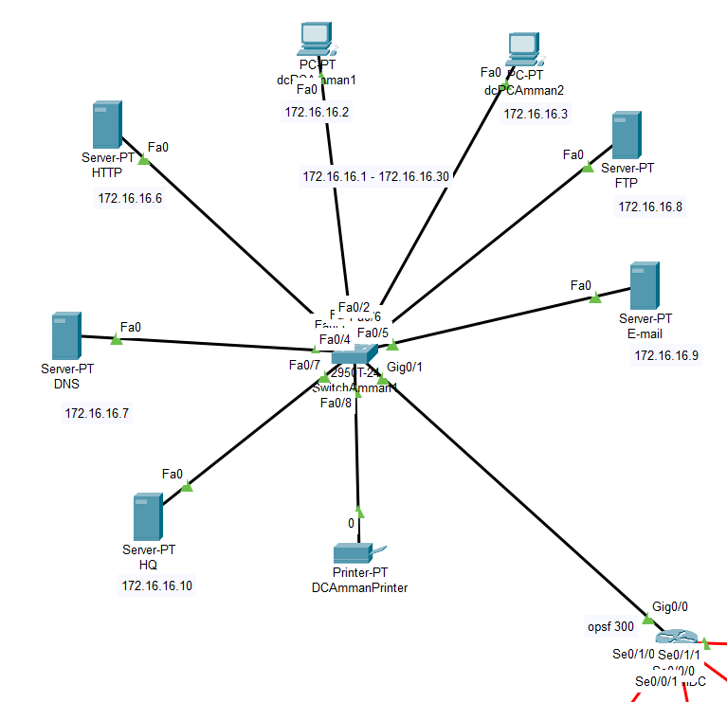

For Amman There are two LAN networks

The First for the data center Above

There are two PCS for administrators, and they have more than the clients for the permissions in the FTP server like the employees can write and read but for the admin can delete, write, read, list, rename

5 servers (the best way to stay at the safe side if one server get down to not get failure for all of them, there (Email server / HTTP server / DNS sever / DHCP server / FTP server), The IP address put static for the servers.

I use Email server to get the employee can communicate with each other with emails with accounts created from there

The HTTP server to browsing and can secure the website that open from the employee

The DHCP server to put the Ip address for all the devices on all LANs with no exhaustion

The FTP server to the devices can upload or read or delete or list or rename the files

The DNS it can matching with the Ip address with the name

All the above connect directly to the switch with a coaxial cable and start with each one from ethernet and the switch connect to a router with the gigabit ethernet cable

There is a printer and it connect directly to the switch

|  |  |
| --- | --- |
| Servers | IP address |
| DHCP | 172.16.16.10 |
| FTP | 172.16.16.8 |
| Email | 172.16.16.9 |
| DNS | 172.16.16.7 |
| HTTP | 172.16.16.6 |

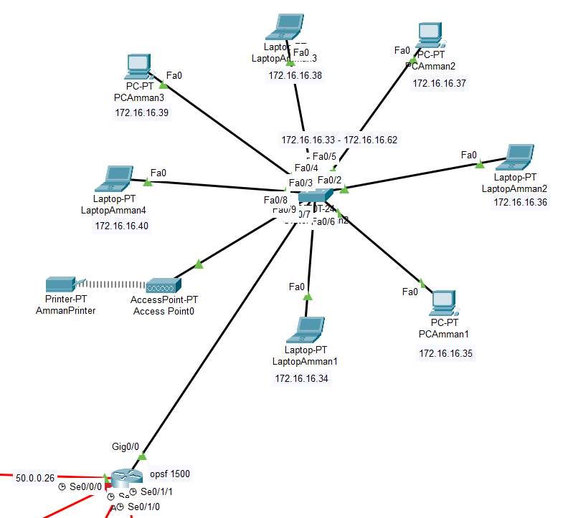

The other LAN in Amman

I put 7 computers in one place and give the IP addresses from the DHCP not static, so it’s an office And I connect them to the switch that connected to a router

I put a wi-fi access

A printer and connected it wirelessly and take an IP address from the DHCP

(For the other LAN it’s the same of Amman in how I put them and the number and the connectivity)

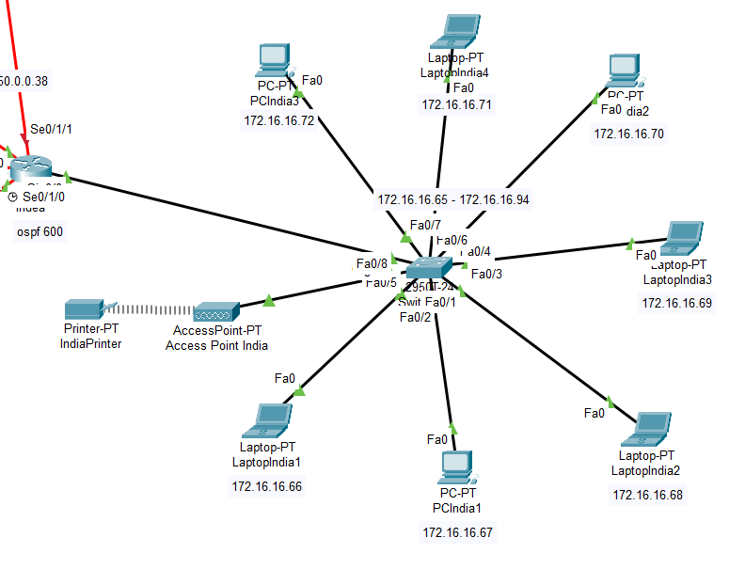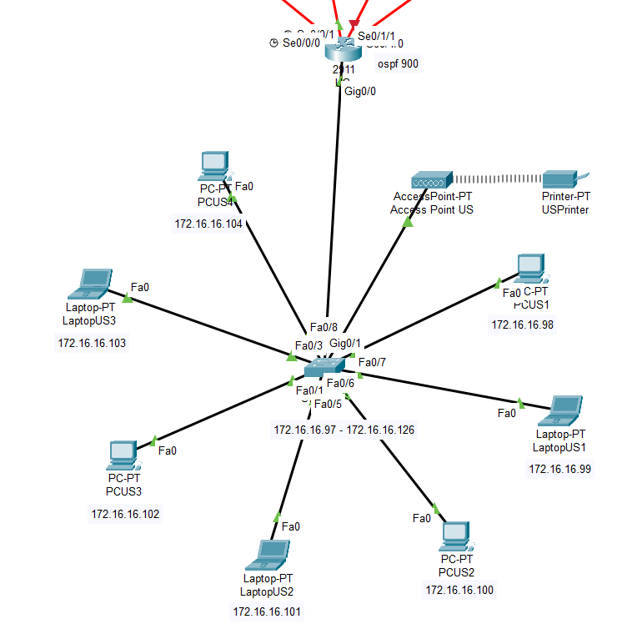

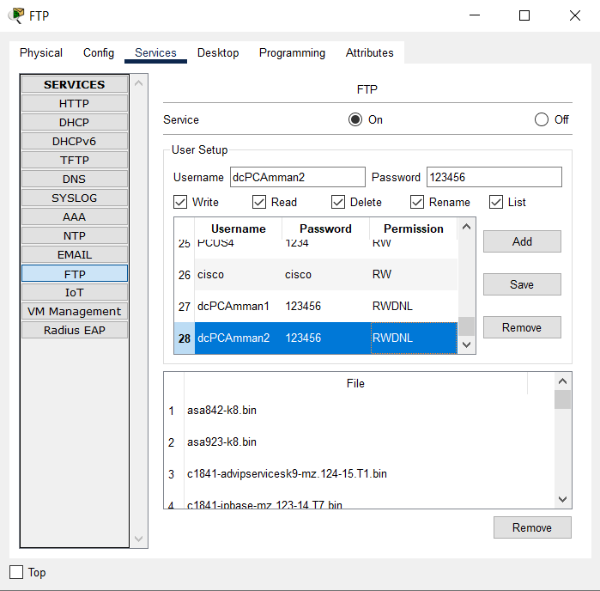How I do the servers?!

For FTP server I go to the desktop choose the Ip address and put the Ip address static and go to the FTP services and create an account for every device, so I put the username the name of the device and the password 1234 for employee and 123456 for admins, the permission is different, I give the employee just Write and read because they just need to be able to share and transfer files, and the administrators have all permissions (delete, write, read, list, rename).

2- For Email server I do the same, I go to the desktop choose the Ip address and put the Ip address static and go to the Email services and create an account for every device, and I create an account for each device and the user the name of the device and the password 12345 and I put the domain ( jgames.com ) and add it on the DNS server, so it’s be ( [dcPCAmman1@jgames.com](mailto:dcPCAmman1@jgames.com) ), after that I go to every device and add this information, the name and the username the same of the device and the password 12345, the email address (the name of device [@jgames.com](mailto:device@jgames.com) ), and on the middle the Ip address for Email server and save, and I finish this server.

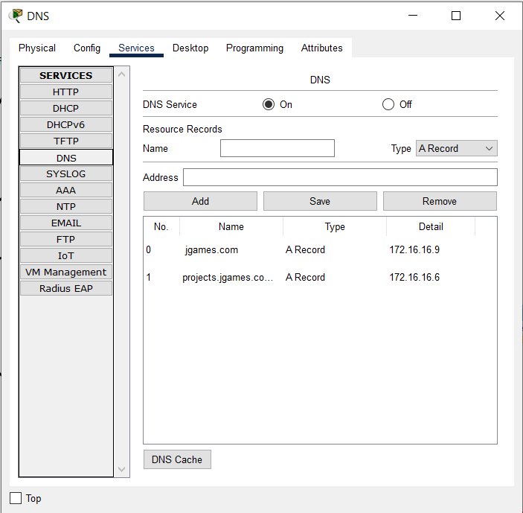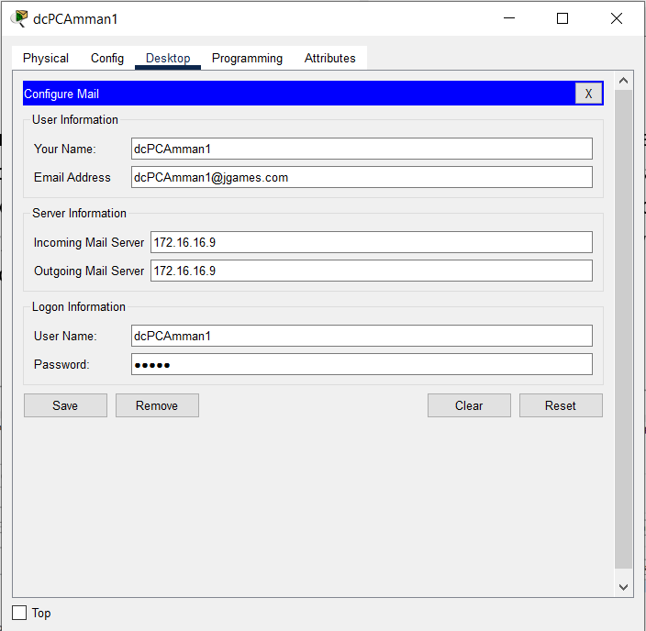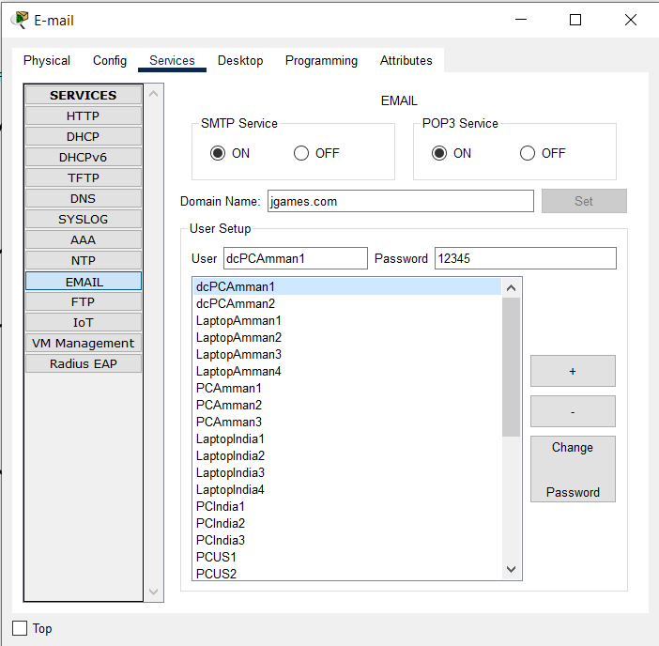

3- for the HTTP server, I go to the desktop choose the Ip address and put the Ip address static and go to the HTTP services, and I put it and I change the HTTP to off, HTTPS stay on, (for security reasons)

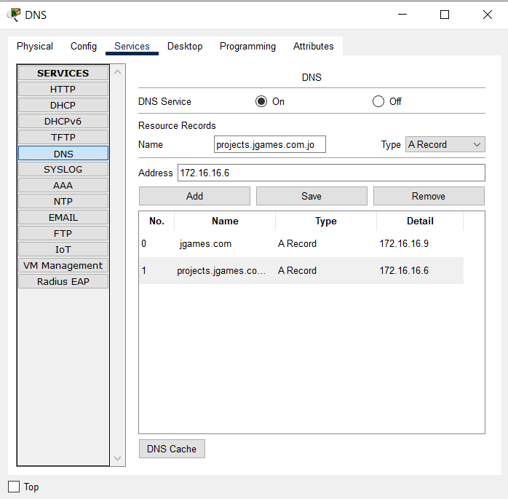

4-for the DNS server, I go to the desktop choose the Ip address and put the Ip address static and go to the DNS services, I change it to on and put the URL or the domain in the name and in the Address the IP address for the server, on this case (HTTP/Email), and save it

5- for the DHCP, I go to server pool and put it all zeros, I put the name of the router on the pool name and put the default gateway for the LAN I do it for and the IP address for the DNS server and on the start Ip address I put the Ip address I want from the DHCP start to Distribute to the LAN and put the subnet mask, and the maximum number that will give to the employee, and add it.

(I add a 3 pool for the future on the DHCP if the network will Growth)

After that I do it for every LAN And go the router, CLI, and do the (enable) command, (configure terminal) command, interface g 0/0 or whatever the port, write the a (ip helper-address) command and do it for every router, and now it work and can send the message from the device to DHCP.

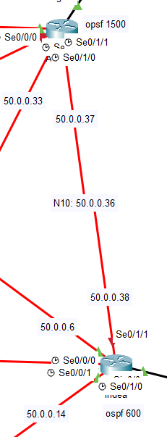

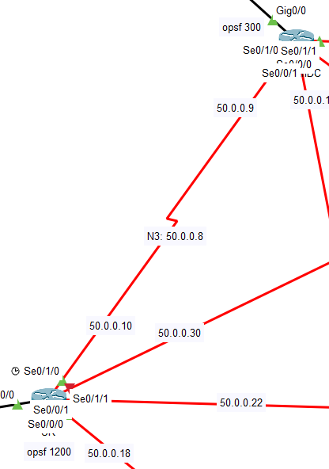

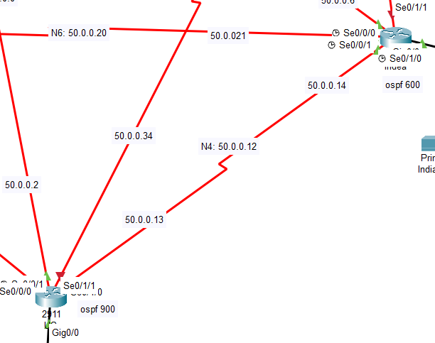

I put it all of them connect to each one of the routers, so every router connects to four different routers, why? It’s the best if anything happens to any serial cable the router can communicate with any router it wants with no failure or down the whole network for this LAN or if any other LAN want to send something or receive from it.

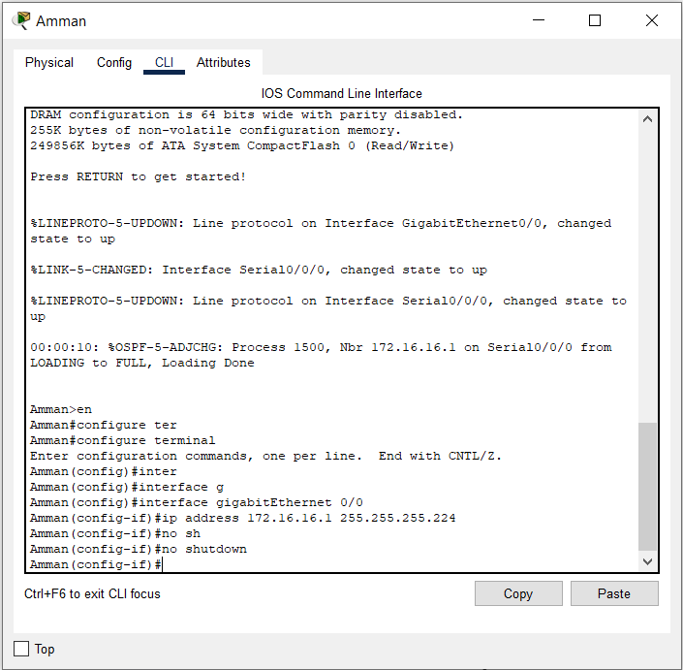

**How I do the router configuration?**

So I go to every router and turn it off and add the serial port and turn it on, after that I add a serial cable

I go to the router and click on CLI, so I start with (enable) command and move to (configure terminal) command to configuration with more Accessibility what I want to add like IP (I don’t have it to before) so I can now just (interface) command and put the name of the port I want like ( (interface gigabitEthernet0/0) / (interface g0/0) or (interface serial0/0/0) / (interface s0/0/0) )

After that now I can put an Ip address or delete it add / remove and to do that I write (ip address / the Ip address I want / the mac Ip) like

(ip address 172.16.16.1 255.255.255.224) >>> this on gigabitEthernet0

(ip address 50.0.0.1 255255.255.252) >>> this on serial

and after we do that it still down why? Because I need to write (no shutdown) command and click ok to get up … now the IP I wrote it add to this router and this interface and I do this with every LAN or serial

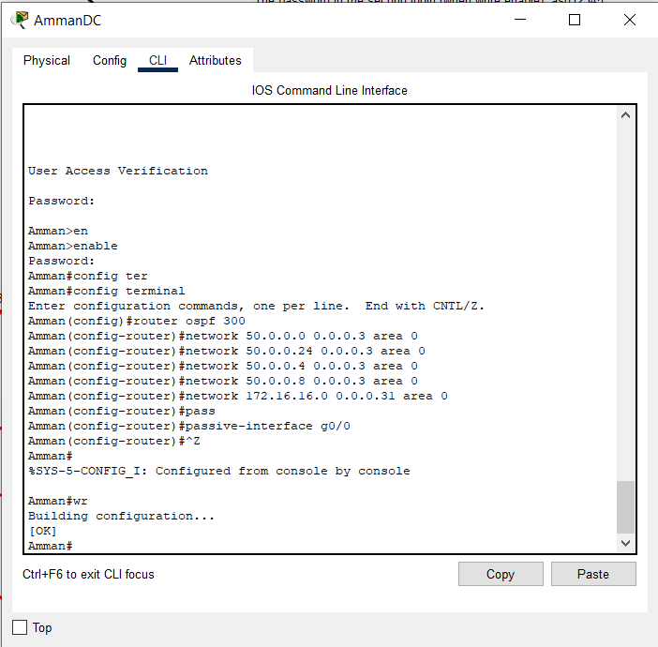do I Finish? Still no, I need to do the OSPF between the routers to know each other

for it I go to every router and write (enable) command, (configuration terminal) command, (router ospf 300/600/900/1200/1500) command, start from (router ospf 300), now write (network) command, (network / network IP (0.0.0.3/0.0.0.31) area 0), so

(network 50 0.0.0.0 0.0.0.3 area 0) or

(network 172.16.16.32 0.0.0.31 area 0)

And I do it for every serial or coaxial cable connect directly with this router

After that I do the (passive-interface) command, with the LAN that connected with directly like

(passive-interface g0/0)

And after I do this for all the routers, I finish it and I can see that from (sh ip route) command, and it shows that the router can see all the serials on the network

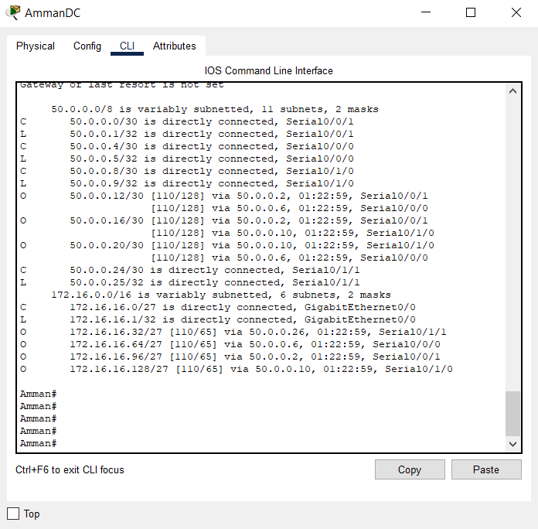

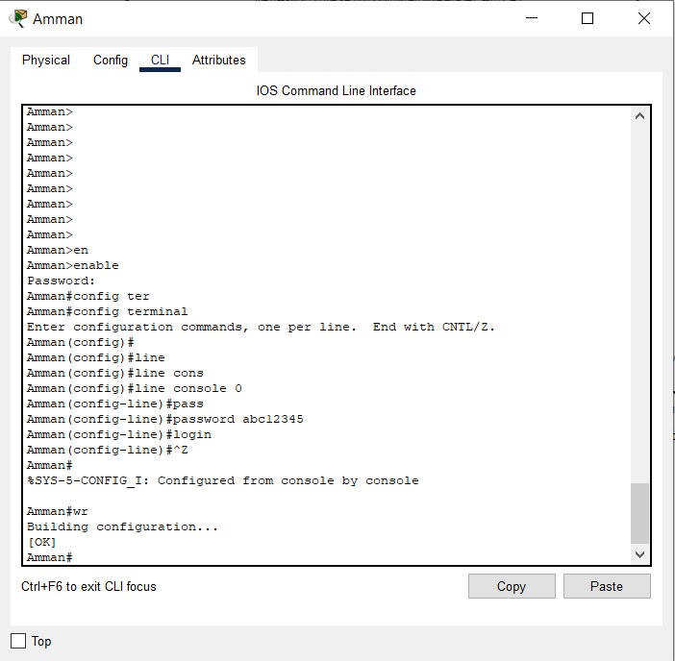After that I do a little thing for security

I put for all the routers the same two passwords

For the first I go to every router, CLI, write (enable) command, (configure terminal) command, (line console 0) command, (password) command (password abc12345), (login) command.

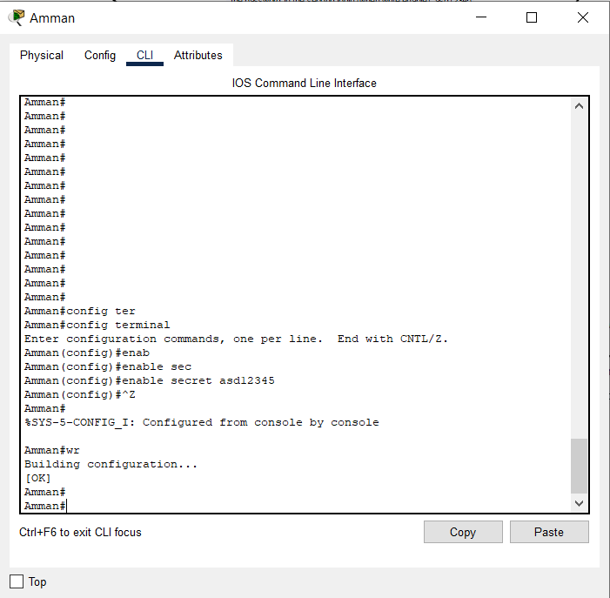

Now for the other password go to (configure terminal) command, and write (enable secret) command, (enable secret asd12345), and just and now there are two passwords.

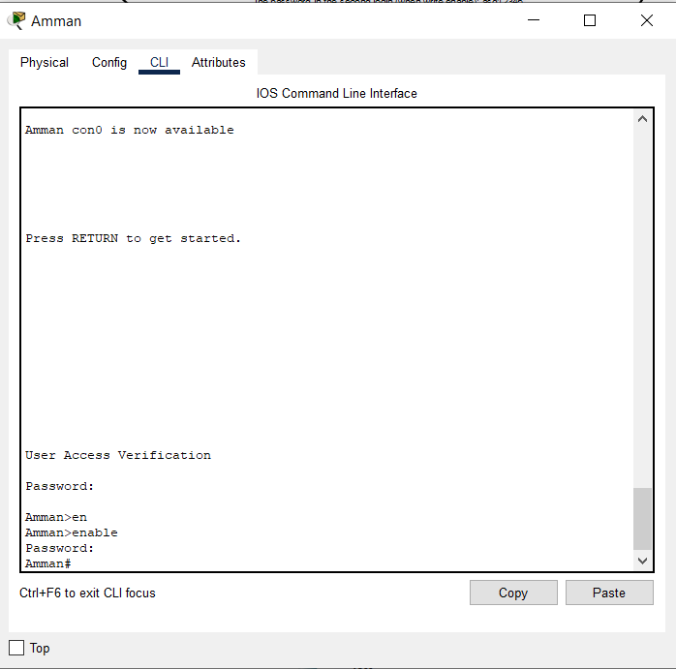**

This what I mean about I connect every router to four routers (Full-Mesh)

To protect any network from getting down, to be more secure, for the data center have the own router

**2- A test plan**

The servers (Email server / HTTP server / DNS sever / DHCP server / FTP server), and the connectivity between the computers in different LANs

|  |  |  |
| --- | --- | --- |
| What to be tested | Tools or commands used for testing | Expected results |
| The connectivity between the computers | (ping) command  (ping the Ip address for the device I want to that I can contact with it or not (see me or not))  From Device 172.16.16.40 to device 172.16.16.1  (ping 172.16.16.1) | Show me that is 4 replay and 3 in the first time because the (ARP), and no 4 lost replays for it |
| The connectivity between the routers | Go to the router, CLI, (enable) command, (sh ip route) command | Show all the serial port for every router even its not connected directly |
| HTTP server | The web browser | when I enter HTTP URL on the web browser Show me (server rest connection), and show me the page when I enter HTTPS |
| Email server | Two different devices  Email Account for each other | The first device when compose Email sent the Email shows (send success) and the second employee receive it and shows (receive Mail success)  The employee be able to send and receive emails for each other |
| DNS server | (nslookup) command | Show the server’s name and the address the same that Ip DNS server add to the device |
| DHCP server | A Device on every LAN | When go to the device and change the Ip address from static to DHCP shows (DHCP request successful) and do it for every LAN and if the same result so there is no mistake on it |
| FTP server | (FTP) command  (FTP the Ip address for FTP server)  (put) command  (get) command  (put/get the file name) | The employee be able to share and transfer files with each other |

**­­­­3- \***

|  |  |  |  |  |  |  |
| --- | --- | --- | --- | --- | --- | --- |
|  | Daily | Weakly | Monthly | Quarterly | 6 Monthly | Annually |
| Check from the backups |  |  |  |  |  |  |
| Check from the servers’ room |  |  |  |  |  |  |
| Do a Test backups |  |  |  |  |  |  |
| Check from the cables |  |  |  |  |  |  |
| Check logs and licenses |  |  |  |  |  |  |
| Check infected machines |  |  |  |  |  |  |
| Check the response time utilization and latency on the main WAN connections |  |  |  |  |  |  |
| Check Windows services on all the Windows servers |  |  |  |  |  |  |
| Check if there any critical Windows updates |  |  |  |  |  |  |
| Check security logs on the servers |  |  |  |  |  |  |
| Look for unauthorized access attempts |  |  |  |  |  |  |
| Restart for all the servers that didn’t restart in the past 6 months |  |  |  |  |  |  |
| Check backup retention |  |  |  |  |  |  |
| Check account has been lockouts for any activity that suspicious |  |  |  |  |  |  |
| Check from disk space availability of File for the servers |  |  |  |  |  |  |
| Review and reset the Service accounts' passwords |  |  |  |  |  |  |
| Update the network Diagrams |  |  |  |  |  |  |

**Part3:**

1-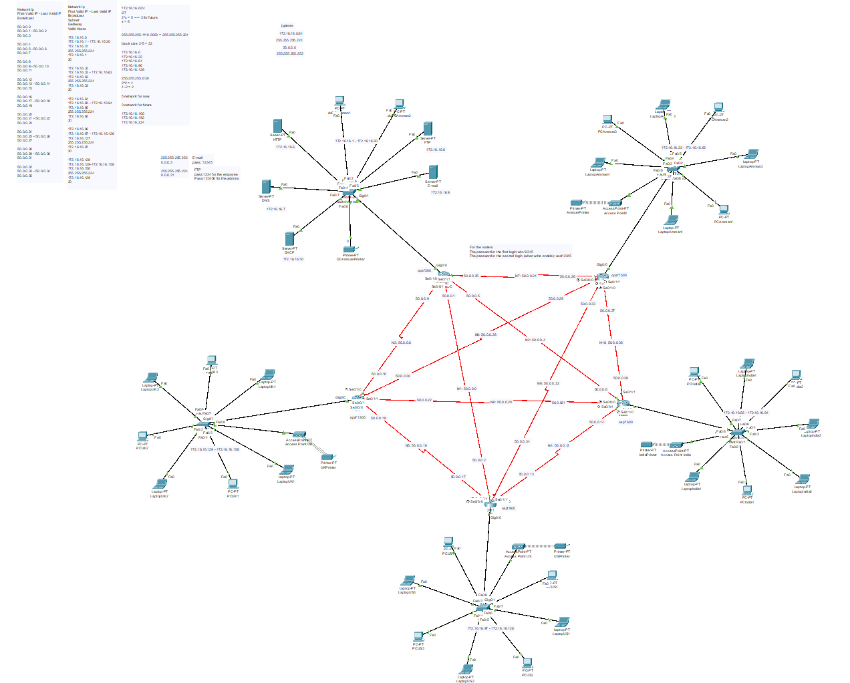

And this is the WAN after I do all the LAN networks

After I do the tests and the changes / the routers and the WANs / the serial cables / the servers / the switches / the devises / the printers / the wi-fi access

**2- Conduct verification**

**1-**For the connectivity, I go to the device I want to send from it to another, to the desktop, choose command prompt, do (ping) command (ping the ip address for the computer I want to communicate with) like

(ping 172.16.16.38) and press Enter if give me like the picture above or lost one for the first time (ARP) and there is no 4 lost for it so it can communicate and it work

**2-**for the DNS server and know the information about it and be sure that the device see the server, I go to the device I want, I go the desktop, the Ip address, and add the DNS (if it was static but with me it add it directly from DHCP server), then go to the desktop again, choose command prompt, then choose command prompt and use (nslookup) command, it will show you the server name and the Ip address of it

**3-**for FTP server, For this test we need two devices one to Write (upload file) and the second to see the uploaded file from the first device, we go to the first device, desktop, choose Text editor That we can create a file, I create (amman.txt) from there, then choose command prompt, write (dir) command, it will appear what I create, now we need to upload it, use (FTP) command like (FTP The Ip address for FTP server), after that it will ask for the username and password, so we put it to confirm that we have the permission, and we need to write (?) to see all the commands that we can do it, but we need to choose something that we have the permission to do it, so we choose what we want, here we choose (put) after that write the name of the file to upload it (put amman.txt), now go to the other device you want to take the file from, desktop, command prompt, the same what we do above from the ftp and the username and password until (?), we choose get and put the file name (get amman.txt) and now it’s on the second device.

We can see how I create and upload the file so it’s on the server, and how it’s on the second devise so its work.

The first device (PCAmman1) that create and upload the file to the server

The second device (PCIndia1) that download the file and have it on the device know

**3-** The test results are the same as what I expected and wanted from the client

From the web and the (DNS / Email / FTP / DHCP / HTTP) server / connectivity between routers and devices.

**4-**

For the enhancements on the network, I can Recommend Making the security aspect better, from the Email accounts put a different password for every employee, and for the FTP accounts, and to put a way to secure the network from everything like the firewall, secure the routers more, increase the speed for transmission data.

For the network can grow up to 3 network LANs, and add 15 devices from the DHCP for the LANs are already exist, and I can add 3 networks for the growth in the future, without any change with the subnetting

3 networks for future

172.16.16.160

172.16.16.192

172.16.16.224

I do the subnetting for every LAN so can get up to 30 hosts, but the client wants up to 22 employees so I put the maximum number of users up to 22, so if any device added to the network can easily take an Ip address from the DHCP server without any problems, it just needs to change it from static to DHCP for every new device.

If the client wants to open another LANs in any place, we can add up to 22 devices and we need just to connect them to a switch with a router (if it need) and connect the router with the others and just need to write (ip helper) command on the router that connected with and can easily take Ip address, and after that just need an account on the Email And FTP servers.

**5-** **

The importance of network optimization lies in the ability to prepare the business for the future and if didn't do not update it, the network will become slow and vulnerable to attack and delay

For the security there are many of tools and ways that we can use it and Strengthen the Security by it

The first recommendation (Firewall):

It can defend the devices against threats, and Filter, Monitor, and Control the traffic, so if anyone wants to access it need permission to access the data, Prevents Hacking Because it prevents hackers from getting unauthorized access to the system, data, Email. It gives an Enhanced privacy.

increase the speed for transmission data

It can be a lot different when the employee can access to the files and websites, or send email, upload and download, it can be helpful in the work by make the employee more productive, and the application run as fast as it can, and that’s mean more work done

For the employee accounts put a different password for each one, so if that anyone threats one Email can’t get into another Email or FTP.

I put 5 routers to be more secure but put two passwords, can use a third password, can use different passwords for all the routers.

**6-**

it needs more cost and a lot of work and cables comparison with the other networks

Put a different password for every router in the network for the security, if one can get in the network with no permission and know the two passwords can get it down.

If the DHCP server get down the employee can’t get to the compony services

Didn’t put a different password for each employee for the emails and FTP

Reference

* * Supertechman.com.au. 2022. *Server and Network Maintenance Checklist -*. [online] Available at: <https://supertechman.com.au/server-and-network-maintenance-checklist/> [Accessed 16 June 2022].
* ** More, R., 2022. *How to Improve the Network Security for Your Home or Office*. [online] Help Desk Geek. Available at: <https://helpdeskgeek.com/how-to/how-to-improve-the-network-security-for-your-home-or-office/> [Accessed 16 June 2022].
* ** Supertechman.com.au. 2022. *Server and Network Maintenance Checklist -*. [online] Available at: <https://supertechman.com.au/server-and-network-maintenance-checklist/> [Accessed 16 June 2022].
* ** Comparitech. 2022. *WAN optimization - 3 tools to optimize wide area networks*. [online] Available at: <https://www.comparitech.com/net-admin/best-tools-wan-optimization/> [Accessed 16 June 2022].